**Downloading Documents from Auditor's Website**

Go to the county Auditor’s website at <http://chtylerapp/recorder/web/>

Click on the ‘I Acknowledge’ button.

Normally, recorded documents will be downloaded from the Auditor’s website for our processes two days after recording. For example, if today’s date is the 15th, download and process documents recorded on the 13th.

**PRINTING DOCUMENTS**

Enter the date range to be printed. For example, 06/13/2019 start date and 06/13/2019 end date.

To select multiple documents:

* **Search All Types** (unclick this box) ->   
  **Click** on document name (Affidavit, Affidavit – Lack of Probate… ect) while holding **“Ctrl”** key   
  Click **SEARCH -> Add All to My Images, -> Download My Images ->**  **Print**

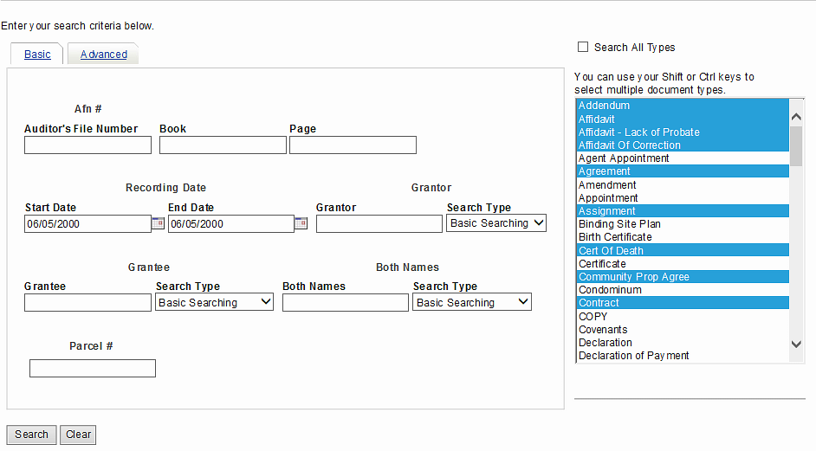

|  |  |
| --- | --- |
| * Addendum | * Forfeiture |
| * Affidavit | * Judgment |
| * Affidavit – Lack of Probate | * Lease |
| * Affidavit of Correction | * Miscellaneous |
| * Agreement | * Modification |
| * Cert of Death | * Multiple Title Documents |
| * Community Prop Agree | * Order |
| * Contract | * Ordinance |
| * Deed | * Purchasers Assign |
| * Dissolution | * Resolution |
| * ERROR CORRECTION | * Sellers Assignment |